## Honor Education

Scoping start date: n/a

Implementation Completed Date (Go live date): n/a

MSA Signature Date: Feb 29, 2024

GTM POC: Skoro

ERP: NS

Tax Integration: No Tax

### 

### Key people at Merchant

### Fractional Head of Finance: Yoav Cohen <[yoav@honor.education](mailto:yoav@honor.education)>

* + Ex-colleague at Latch

### CEO: Joel Podolny <[joel@honor.education](mailto:joel@honor.education)>

* + Signatory

### Company summary

Provides education software to schools and universities   
  
AM Notes

* Yoav, the fractional accountant, is a former colleague of Ali, Deepak, and Skoro at Latch
* Yoav needs to be better trained on using the product, often just emails instead of doing it himself

### Billing model

* Standard flat-line billing
* They’re exploring a more nuanced channel distribution model, but have not yet implemented

### Contract Processing Steps

* As of 12/12/2024 - any new client should be marked “bill to merchant”
* Integration Item should always be “Sales”
* Default language in contract can be ambiguous. The Base price is charged annually, overage fees are assessed quarterly. Example Below:

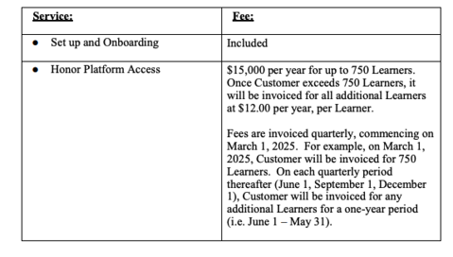

* In this example: $15,000 is charged annually and “additional learner fees” are assessed quarterly, starting on June 1.

### Events Processing (if necessary)

* Not yet applicable, but may be later in 2024

### Customer Information

* n/a

### Feature Requests

* n/a

### Rewatch Calls

* n/a